PROJECT REPORT
1.INTRODUCTION
1.1. OVERVIEW
The project in the zoho books for Dream homes realty involves the creation of financial statement, which includes income statement,balance sheet and cash flow statement these statement are essential to assess the financial health of the company.
1.2. PURPOSE
By creating a financial statement I the zoho books we can gain deep understanding of our company's financial standing and make strategic adjustments to improve your performance and it helps in identify the trends
2.PROBLEM DEFINITION & DESIGN THINKING
2.1 EMPHATHY MAP

2.2 IDEATION & BRAINSTROMING MAP
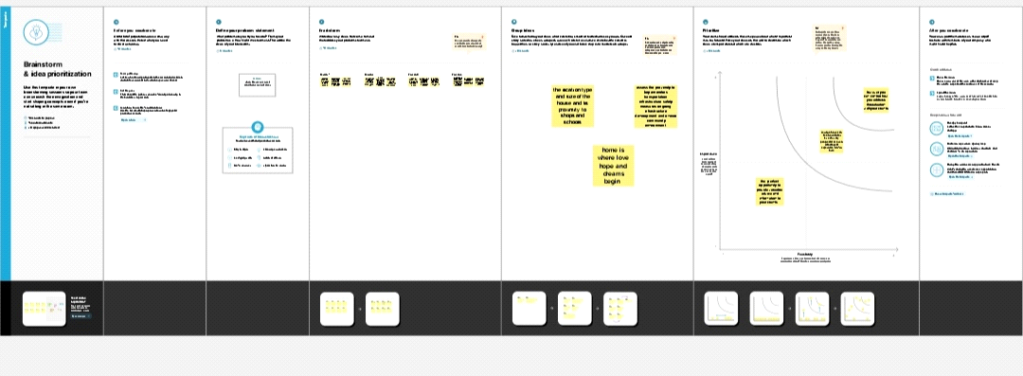
3.RESULT
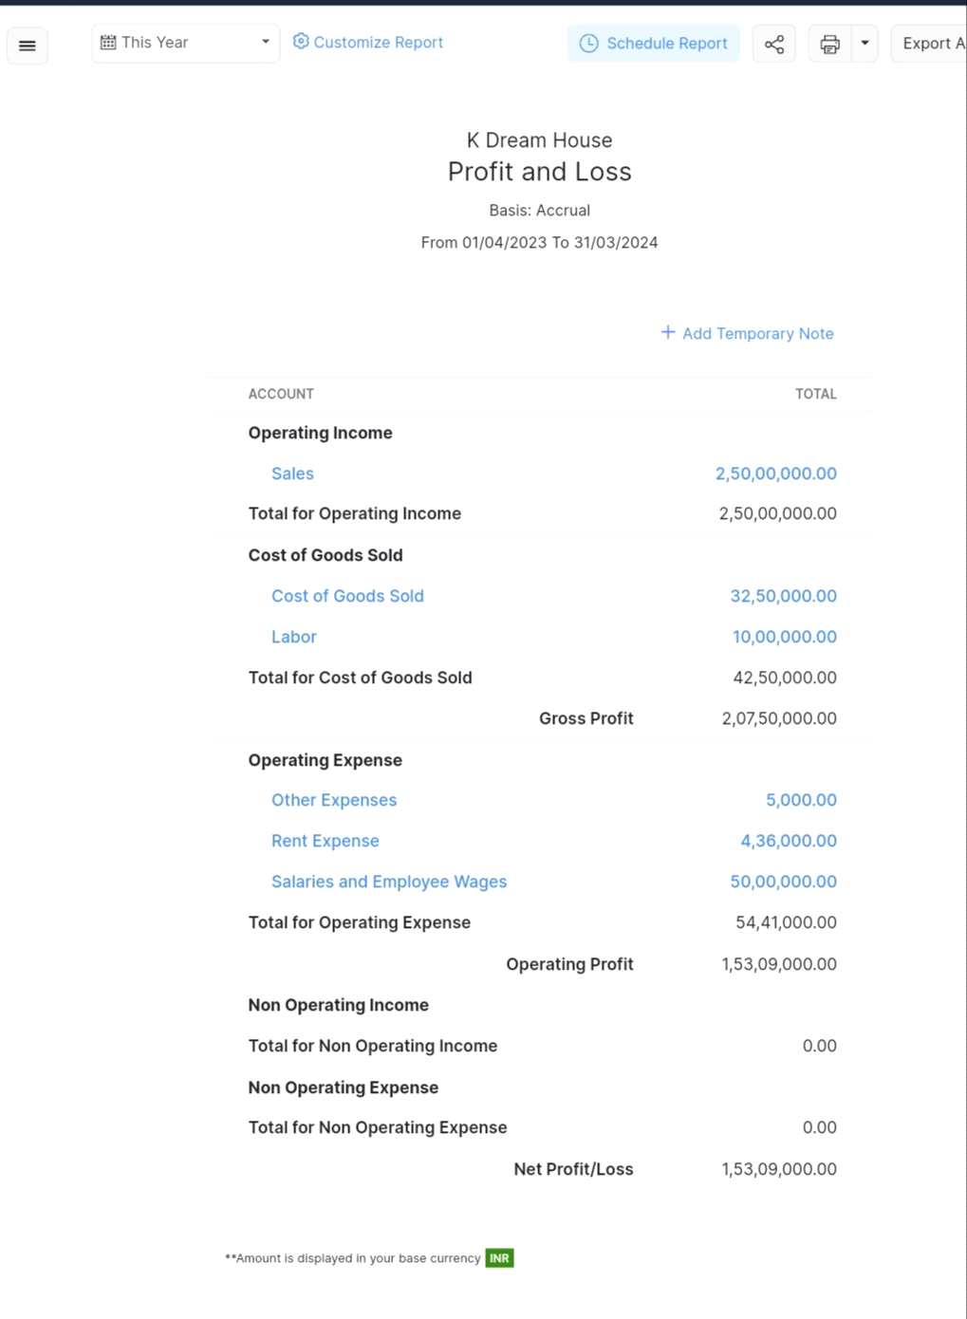
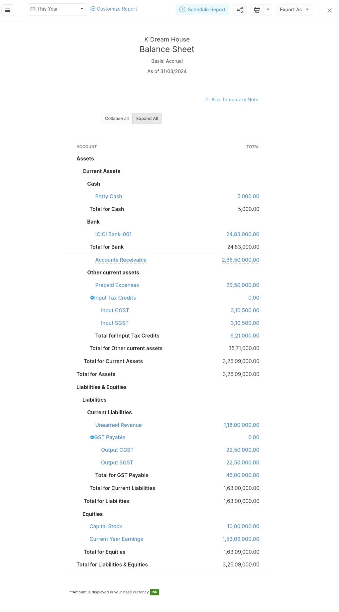

4. ADVANTAGE & DISADVANTAGE
1.User-friendly interface: Zoho Books has a simple and intuitive interface that is easy to use, even for those with little accounting knowlledge.
2.Affordable pricing: Zoho Books offers affordable pricing plans that cater to small business and freelancer
Disadvantags of Zoho Books:
1. Limited features: Zoho Books lacks some features that other accounting software offers, such as payroll, job costing, and inventory tracking
2. Customer support: Some users have reported difficulty in getting quick and efficient customer support
5. APPLICATIONS
Zoho Books can also be applid in other areas, including:
1. Inventory management: Zoho Books has a basic inventory managament functionality that allows businesses to track their inventory levels and monitor stock movement
2. CRM Integration: Zoho Books can be integrated with Zoho CRM to improve sales pipeline management.
6. CONCLUSION
To summarize the project done in Zoho Books on financial statements,the following can be presented:

All three financial statements generated using Zoho Books will give an overview of DREAM HOMES REALTY 'financial health, which will help the management make informed decisions to improve the company's profitability and sustainability.
7.FUTURE SCOPE
As for enhancement that can be made for future use, some suggestions are:
1. Customizable reporting: Zoho Books can consider providing more options for the customization of reports.
2.Improved mobile app: Zoho Books could add more functionalitiesand features to its mobile app to enhance on-the-go accounting and make it more convenient for users to access their financial information.

